FRG FUNDRAISING OPPORTUNITIES AT
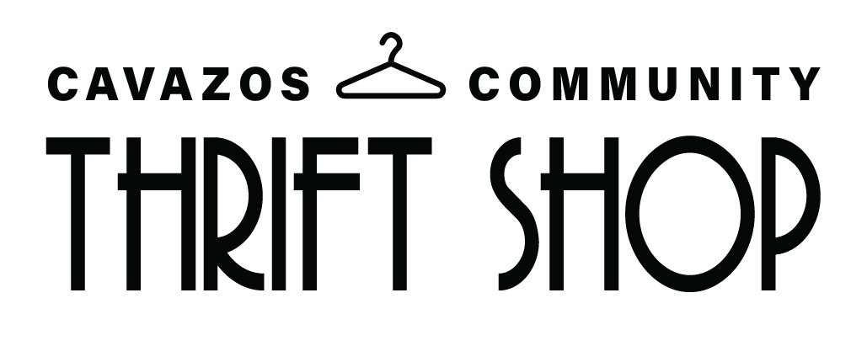

Earn Up To $200 for your SFRG!

A maximum of two (2) people may volunteer to work each shift in its entirety. The work shift is Tuesdays -Thursdays from 0900 to 1400. Volunteers will be contracted to complete 20 hours of volunteer service in a 1 month period. Volunteer(s) must cover 4 shifts of 5 hours.
The duties are to include, but are not limited to pulling expired items, emptying the donation bin, tagging items, straightening merchandise and miscellaneous tasks. A 30 minute lunch break is included in the day as scheduled by the manager. Volunteers are responsible for their own lunch.
No childcare is provided, and no children under the age of 16 should be brought to the Thrift Shop by volunteers.
The SFRG representative who signed the contract may pick up the check at the Thrift Shop on the 1st business day of the month following the contact period.
ALL SFRGs must get approval through their Command and DFMWR prior to entering into a contract with the Cavazos Community Thrift Shop.
MWR Representative Cavazos Community
(254) 287-0240 (254) 532-2948
Building 194, 37th St
Fort Cavazos TX 76544

